**Experiment 4.4**

**Aim:** Working with directories,rename file,copy file

**Code:**

1)Create a directory in current working directory

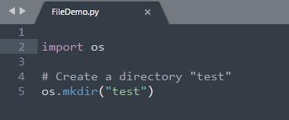

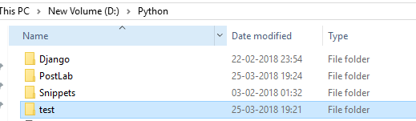

2)Change working directory and display current directory

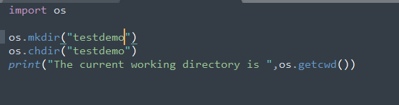





3)Remove a directory by passing file name as argument

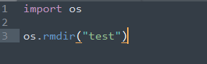

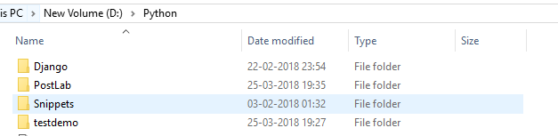

4)Rename a file and delete a file

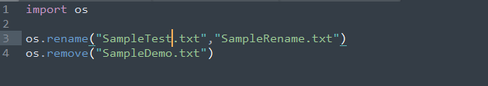

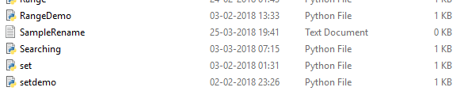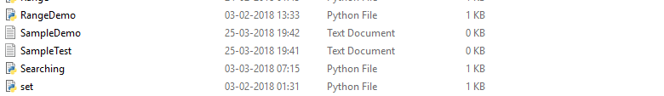

5)Copy contents of file

